FX Quote Lift: Gradient Descent + scikit-learn
Short name: FX_Quote_GD_Sklearn · Currency-conversion industry adaptation of C1_W3 Lab06 + Lab07

Problem Statement
An FX conversion platform must decide which live quotes a client will lift. Lab06/07 teach logistic GD and sklearn on a tumor-style toy. The desk needs the same optimizer with FX labels: edge vs mid, urgency, quoted spread, and a USD/CRC retail markup. Three gaps remain if you only run the original labs: default sklearn is L2 so weights will not match unregularized GD; there is no last-look / blotter-size simulation; there is no voice for pricing, sales, treasury, or a retail converter.

Solution Strategy
- Keep the six Coursera coordinates so the published gradient check still holds; relabel them as edge_score, urgency_score, lifted.
- Loop + vectorized gradient, batch GD (α=0.1, 10k steps), P(lift) field and 0.5 contour.
- sklearn C=∞ vs default L2 overlay — compare fill-rate, not raw w.
- 1-D spread (tightness feature) + 60-quote stream + USD→CRC markup cart.
- Monte-Carlo of α, book size, and 6% last-look label flips; four audience paragraphs.

Solution
Gradient check matches Lab06. GD reaches w≈(5.281, 5.078), b≈−14.222, J≈0.017, in-sample fill-rate 1.0. Retail spread crosses 50% conversion near 15.3 bps. sklearn C=∞ also fills the six quotes at a larger |w|; default L2 shrinks w to ≈(0.90, 0.74) and still scores 1.0. Last-look noise in the simulation is what keeps a live book from looking this clean.
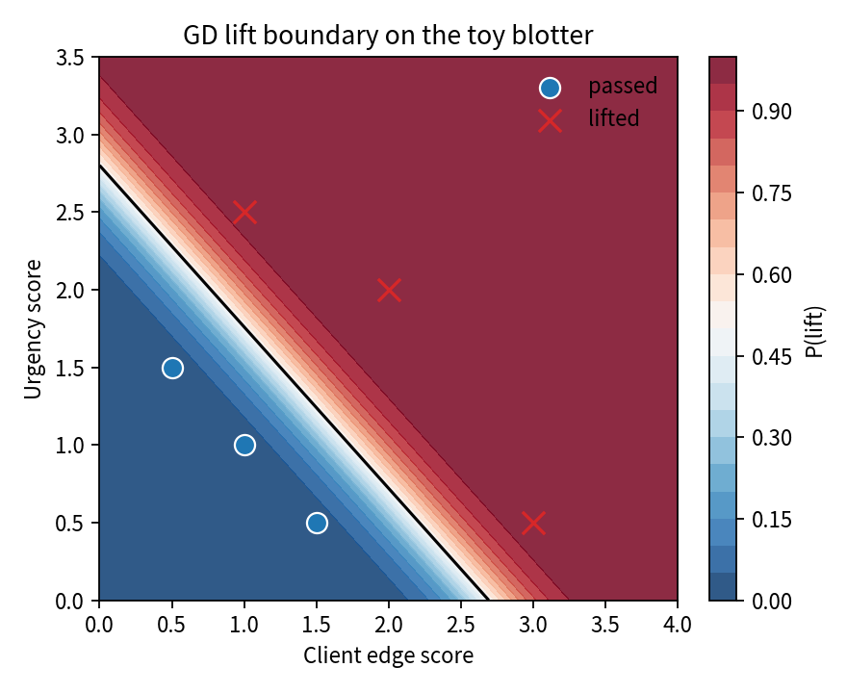  P(lift) field + 0.5 contour | 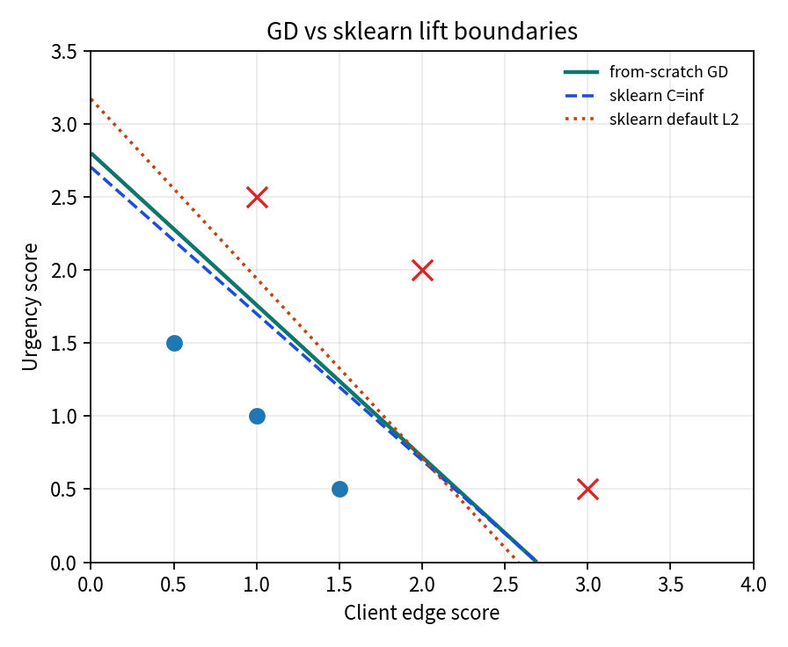  GD vs C=∞ vs default L2

Key Takeaways
- Same (f−y)x gradient as linear GD; f is now P(lift) = σ(z).
- Clip z and f. If J rises, the learning rate is too aggressive for that blotter.
- sklearn default is L2. Unit-test fill-rate and the boundary, not coefficient equality.
- Threshold = sales appetite; C = smoothness; last-look flips = data quality.
- Four voices, same facts: quant formulas, dealer cutoffs, executive L2 caveat, retail “fairer quote → more Convert taps.”

